**DAILY ONLINE ACTIVITIES SUMMARY**

|  |  |  |  |  |  |  |  |  |
| --- | --- | --- | --- | --- | --- | --- | --- | --- |
| **Date:** | **15/06/2020** | | | | | **Name:** | **NAIPUNYA VINOD NAIK** | |
| **Sem & Sec** | **IV SEM & A SECTION** | | | | | **USN:** | **4AL18CS050** | |
| **Online Test Summary** | | | | | | | | |
| **Subject** | | **NOT CONDUCTED** | | | | | | |
| **Max. Marks** | | **-----------------** | | **Score** | | | **--------------------** | |
| **Certification Course Summary** | | | | | | | | |
| **Course** | **A BEGGINER’S TO MICROSOFT EXCEL** | | | | | | | |
| **Certificate Provider** | | | **UDEMY** | | **Duration** | | | **5 HRS** |
| **Coding Challenges** | | | | | | | | |
| **Problem Statement:1)** [Write a Java Program to find if string is K-Palindrome or not](https://github.com/orgs/alvas-education-foundation/teams/2nd-year/discussions/121). | | | | | | | | |
| **Status: EXECUTED** | | | | | | | | |
| **Uploaded the report in Github** | | | | | **YES** | | | |
| **If yes Repository name** | | | | | <https://github.com/naipunya-naik/lockdown-coding/blob/master/JAVA%20CODING/K-palindrome_15-06-2020.java> | | | |
| **Uploaded the report in slack** | | | | | **YES** | | | |

Online Test Details: (Attach the snapshot and briefly write the report for the same).

NO INTERNALS CONDUCTED

Certification Course Details: (Attach the snapshot and briefly write the report for the same)

A BEGINNERS COURSE TO MICROSOFT EXCEL

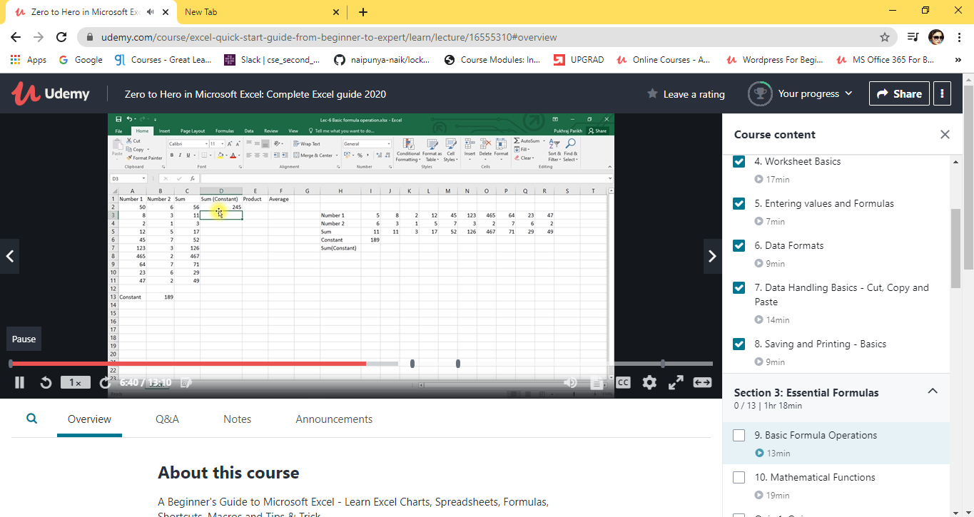

TOPICS LEARNT TODAY ON 15 JUNE 2020:-

* **Section 1: Introduction**
* **Section 2: Excel Basics**
* **Section 3: Essential Formulas**
* **Section 4: Data Tools**
* **Section 5: Formatting data and tables**
* **Section 6: Pivot Table**
* **Section 7: Excel Charts**
* **Section 8: Pivot Charts**

Coding Challenges Details: (Attach the snapshot and briefly write the report for the same)

**PROBLEM STATEMENT**:-[Write a Java Program to find if string is K-Palindrome or not](https://github.com/orgs/alvas-education-foundation/teams/2nd-year/discussions/121).

A string is k palindrome if it can be transformed into a palindrome on removing at most k characters from it. Your task is to complete the function is_k_palin which takes two arguments a string str and a number N . Your function should return true if the string is k palindrome else it should return false.

Input:  
The first line of input is an integer T denoting the number of test cases . Then T test cases follow . Each test case contains a string str and an integer N separated by space.

Output:  
The output will be 1 if the string is k palindrome else 0 .

**Example**  
Input : String - abcdecba, k = 1  
Output : Yes  
String can become palindrome by remo-  
-ving 1 character i.e. either d or e)

Input : String - abcdeca, K = 2  
Output : Yes  
Can become palindrome by removing  
2 characters b and e.

Input : String - acdcb, K = 1  
Output : No  
String can not become palindrome by  
removing only one character.

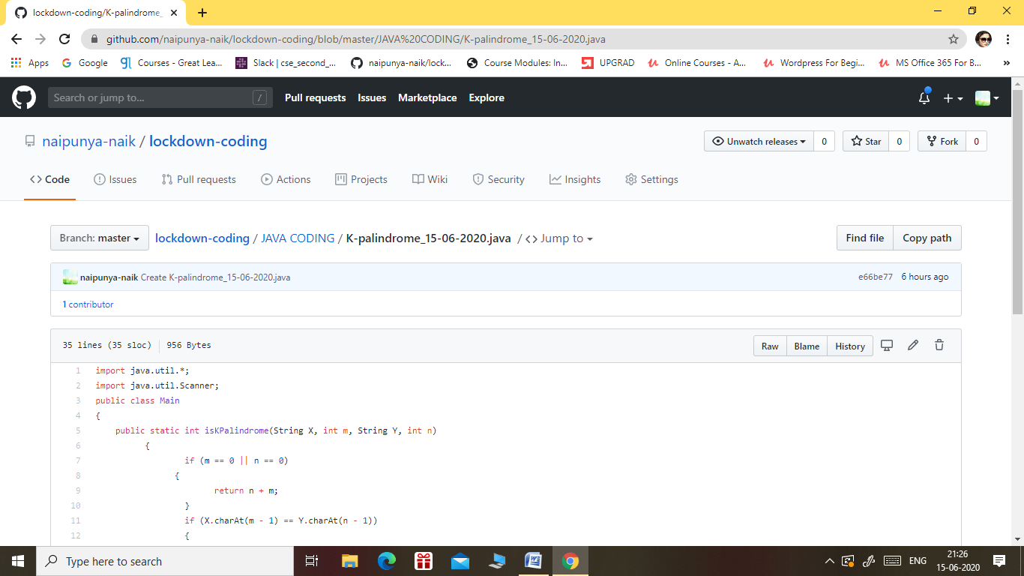

GITHUB REPOSITORY LINK:-

<https://github.com/naipunya-naik/lockdown-coding/blob/master/JAVA%20CODING/K-palindrome_15-06-2020.java>